Queensland Government Building and Construction Training Policy
(Training Policy)

Indigenous Economic Opportunities Plan
for

Remote Discrete Indigenous Communities

About the Indigenous Economic Opportunities Plan (IEOP)
As part of the development of the IEOP , contractors should refer to the Queensland Government Building and Construction Training Policy Guidelines located on the Department of Youth Justice, Employment, Small Business and Training website as well as the processes for Indigenous projects located on the Department of Treaty, Aboriginal and Torres Strait Islander Partnerships, Communities and the Arts (DTATSIPCA) website at Indigenous projects under the Building and Construction Training Policy.

The IEOP is designed to maximise local employment, training and business supply opportunities for Aboriginal and Torres Strait Islander Queenslanders in connection with the eligible building and construction projects.
The IEOP details the minimum, agreed Indigenous economic outcomes and provides flexibility in order for the economic opportunities associated with the project to be maximised for local communities.
The IEOP is negotiated in consultation with the principal (Queensland Government agency), the relevant Aboriginal and Torres Strait Islander council or authority, the relevant employment agency in the community, identified trade suppliers, the Technical Working Group (TWG) meetings can be utilised to source relevant information.
The IEOP is a written agreement between the principal (Queensland Government agency), the applicable Aboriginal and Torres Strait Islander council or authority, and the preferred tenderer(s) and is developed and signed prior to the awarding of the contract and will form a key part of the contract.
The IEOP details the project specific employment, training and business supply opportunities to be adhered to by the successful contractor in order to comply with the Queensland Government Building and Construction Training Policy.
Compliance for Indigenous Projects
The IEOP forms part of the Training Policy compliance requirements for Indigenous projects, and by its signature, the preferred tenderer(s) warrants to comply with the requirements detailed in this IEOP.
The successful contractor will submit as part of the compliance plan an agreed IEOP through the Training Policy Administration System (TPAS), which is located on the Construction Skills Queensland website at http://csq.org.au/for-employers-stakeholders/the-training-policy
The successful contractor is to meet regularly with the principal and an Executive from the relevant Aboriginal and/or Torres Strait Islander council or authority through the TWG. These meetings will occur throughout the project construction to keep all parties informed about the progress against the agreed IEO Plan and to resolve any issues.
The successful contractor, the principal and an Executive representative of the council or authority (Mayor/CEO) will review and sign off on the achievement of outcomes against the agreed IEOP.
The successful contractor will submit as part of the practical completion report, the signed IEOP with final outcomes through the Training Policy Administration System (TPAS) which is located on the Construction Skills Queensland website.

Queensland Government Building and Construction Training Policy
Indigenous Project Summary - IEO Plan and Core Requirements
PROJECT DETAILS
All boxes shaded yellow must be completed |  |  | Date
Total Project Cost (inc GST)  Project No.  Project Type (Build/Civil) |  |  | Project name  Locality  Client/Agency
TRAINING POLICY (MINIMUM) REQUIREMENTS
 |  | Additional Requirement Calculated IEO Plan
Core Requirement
Apprentices/Trainees (new entrants)  Other Workforce  Total Deemed Hours | 0 |  |  |  | $0
 | 0
 | 0
APPROVED INDIGENOUS ECONOMIC OPPORTUNITIES PLAN (IEOP)
Agreed Requirements | Apprentices and Trainees  (new entrants only) | Other Workforce  Employment/Training | Local Indigenous Business Supply/
Core Hours | 0 | 0
Agreed Additional Hours (1) | 0 | 0
Agreed Goods and Services⁽²⁾ |  |  | $0
ACHIEVED EMPLOYMENT, TRAINING and INDIGENOUS BUSINESS OUTCOMES
Achieved Outcomes | Apprentices and Trainees  (new entrants only) |  | Other Workforce  Employment/Training |  | Local Indigenous Business Supply/
Total Core Deemed Hours Achieved (3) | 0 |  | 0
IEO Plan Additional Requirement Achieved (4) |  | 0 | 0 |  | $0
Total IEO Plan Value Achieved (5) | $0 | accredited training over and above the minimum core requirements  opportunities for Indigenous projects and are in addition to the core requirements under the Training Policy.  as part of the core requirement under the Training Policy for apprentices/trainees (new entrants) or other workforce.  Indigenous workers, and accredited training over and above the minimum core requirements as well as the actual local  labour rate plus the actual local Indigenous business supply and/or subcontractor expenditure.
Notes: | Indigenous workers, and employment, training and business supply the Training Policy Administration System (TPAS)  the employment and training of apprentices/trainees, be recorded on TPAS  part of the IEO plan multiplied by $45 per hour
- Agreed additional hours are the employment and training hours for apprentices/trainees,
- The agreed IEO plan refers to the agreed outcomes for local Indigenous
- The total core deemed hours achieved are the total hours recorded in
- IEO plan requirements achieved are the additional hours achieved for Indigenous business supply and/or subcontractor expenditure.These can
- Total IEO plan value achieved is the total additional hours achieved as

The Core Hours to be completed on the below table are optional for the Principal Contractor. **Core Hours must be reported on TPAS
Local Aboriginal and Torres Strait Islander Apprentice and Trainee Employment/Training Hours (New Entrants only). *These hours are recorded
First Name Last Name Engaged as Trade area Employer Agreed Hours Achieved hours
Local Abori_{g}inal and Torres Strait Islander Em_{p}lo_{y}ment/Trainin_{g} Hours. ( Other Workforce₎ These hours are recorded by the contractor on TPAS.

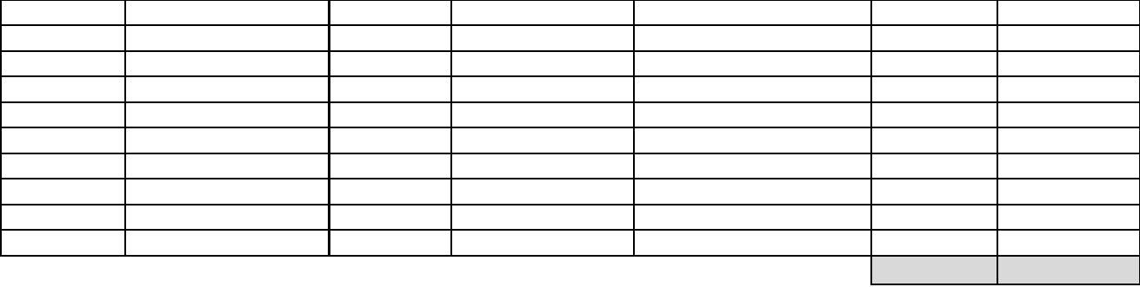
0
0
First Name Last Name Engaged as Trade area Employer or RTO Agreed Hours Achieved hours

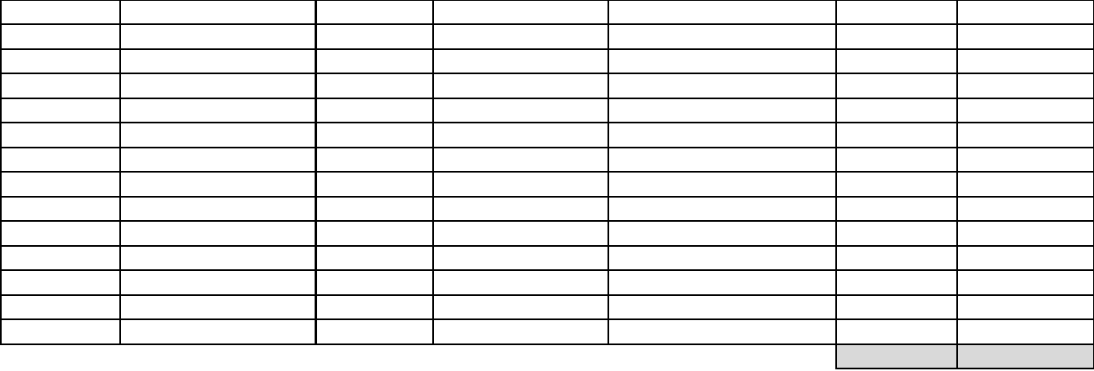
0
0

The table below details the IEO Plan employment requirements to meet compliance for this project.
Local Aboriginal and Torres Strait Islander Apprentice and Trainee Employment/Training Hours (New Entrants only). *Only record hours over and above the core requirement.
First Name Last Name Engaged as Trade area Employer Agreed hours Achieved hours
0
0
Local Aboriginal and Torres Strait Islander Employment/Training Hours. (Other Workforce ) * Only record hours over and above the core requirement.
First Name Last Name Engaged as Trade area Employer or RTO Agreed Hours Achieved hours
0
0

The table below details the IEO Plan local business supply requirements to meet compliance for this project.

Local Aboriginal and Torres Strait Islander Business Supply Local and/or SubcontractorGoods/Services/Businesdetails Supply

Name of Business/Supplier Goods and/or Service | Agreed Achieved

Total Business Supply/Service | 0 | 0

Indigenous Economic Opportunities Plan Agreement

The information provided in this Indigenous Economic Opportunities Plan has been agreed to by {Insert Aboriginal and/or Torres Strait Islander Council or Authority} , {Insert
Tenderer} and {Insert Principal Queensland Government Agency}
Signed of behalf of the Aboriginal and/or Torres Strait Islander Council or authority - Executive Representative
Name: Signature:
Position: Date: / /
Signed on behalf of the tenderer
Name: Signature:
Position: Date: / /
Signed on behalf of Principal Queensland Government Agency
Name: Signature:
Position: Date: / /
1. If the Aboriginal and/or Torres Strait Islander Council and the tenderer is the same, the Council would complete and sign as the tenderer only.

Achievement of outcomes against the agreed Indigenous Economic Opportunities Plan

The information provided in this Indigenous Economic Opportunities Plan has been agreed to by {Insert Aboriginal and/or Torres Strait Islander
Council or Authority}  Name:  Position:  Comment:  Name:  Position:  Comment:  Name:  Position:  Comment: | , {Insert Tenderer} and {Insert Principal Queensland Government Agency}  Signed of behalf of the Aboriginal and/or Torres Strait Islander Council or authority - Executive Representative  Signature:  Date: / /
 | Signed on behalf of the tenderer  Signature:  Date: | / | /
 | Signed on behalf of Principal Queensland Government Agency  Signature:  Date: | / | /

